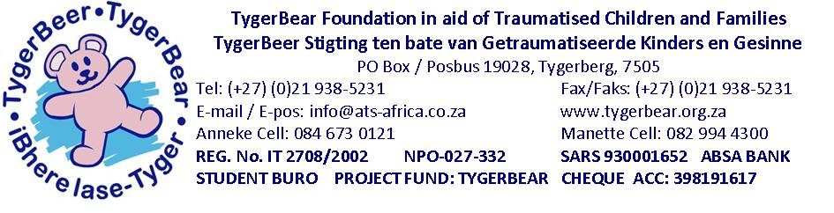
TYGERBEAR CARE CENTRE : WISH LIST
1. Garden:
The garden must still be designed and laid out. Needs: Spades, garden forks, hosepipe, lawnmower and any other items that can be used in the outlay and maintenance e.g. child friendly statues, garden gnomes, plants, garden furniture (benches and chairs), gravel, paving, waterfall etc. Also the opportunity for a corner of the garden to be sponsored with a water feature.
2. Desk
3. Varnish, paintbrushes for wooden gates.
4. Drying racks, ironing board and iron for laundry.
Extendable washing line for outside.
5. Lounge Suite
Child friendly and suitable for 10-12 people
6. Dining Room Table with 12 chairs
Many children do not understand discipline and table manners as well as dining together as a family unit.
7. Cots for the Nursery
8. Mobile baby cabinet to accommodate bath
9. Consumable Stock
- Cleaning materials
- Non-perishable foods
- Toilet paper
- Hand towels
- Disposable nappies

10. Kitchenware – various kitchen equipment including plates, mugs and cutlery
11. Filing cabinet for office and assessment room
12. Large storage containers with lids for toys, clothes etc.

13. Shelves for “loft” room for storage
14. Children books for library
15. Colouring-in books and crayons
16. Children’s Games and educational toys
17. Clay
18. Bubbles
19. Stationary books and pens for school lessons
20. First Aid Kit with emergency supplies
21. Key cupboard
22. Safe
23. Mobile barbecue / Gas barbeque
24. Heaters
25. Fans / mobile air conditioners
26. Bed linen and blankets
27. Mattresses
28. Loose child friendly mats to match existing décor
29. Hand and Bath Towels
30. Adopt-A-Room
Adoption Rooms – there are still 2 rooms available for adoption –
- Nursery R50 000
- Laundry and bathroom R30 000
- Garden as a whole R50 000
Garden corners/benches with sponsors’ names
31. Adopt-A-Child
Financial donations for the operational costs of the Care Centre:
The care for one child may be sponsored at R 4 347.22 per child per month. This includes accommodation, clothes, food, medical supplies, specialized therapy and specialized schooling. (Expenditure breakdown available on request)
32. Safety of children – safety rails on the top of the wall.
Sponsorship for security guard.
33. Sponsorship for salaries of day and night house-mothers, chef, assistant and cleaner.
34. Sponsorship for meals for 14 children.
35. Patio Play Area:
Artificial grass as well as large doll houses.
Plastic Ball-pen and balls
Medium-large inflatable swimming pool

