YOU WILL NEED
32 sts
75g of double knit yarn
1 pair 4mm needles
Stuffing

BODY
Front and back (two identical parts) 16 sts
Starting at the legs, knit two simultaneously or separately.

C/on 16 sts. Garter stitch 34 rows each. 16 rows
Then knit across both legs joining yarn between.
(32 sts for body).
Garter stitch 28 rows. Increase for arms, c/o 16 sts on
either side of body. Garter stitch the following 16 rows (64 sts.), then
c/off on either side of the body (to end arms) and continue on remaining 32 sts.
Garter stitch 40 rows (for head) and c/off LOOSELY.
Remember to c/off top edge of arms and top edge of head 28 rows
loosely, otherwise the arms will pull up and the head won’t
have nice pointy ears. Optional
Stitching 32 sts
TO MADE UP
With right sides together, sew all seams closed leaving a gap at
the top (the head) for stuffing. Turn right side out and stuff
firmly until legs, arms, body and head are well rounded.

HEAD AND FACE 34 rows
Stuff firmly then seam top edges of the head to flat corner-shaped
for the ears. Sew lightly through stuffing at an angle for shape
at corners, keeping stuffing thinly for the ears

16sts 16sts

TYGERBEAR

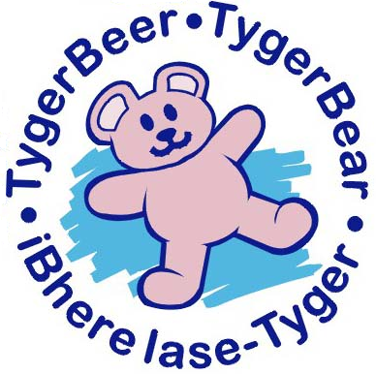

KNITTING
PATTERN

